lOMoARcPSD|28346463



[Create a report depicting features of different types of operating system](https://www.studocu.com/in/document/aj-institute-of-engineering-and-technology/computer-science/create-a-report-depicting-features-of-different-types-of-operating-system/25993399?utm_campaign=shared-document&utm_source=studocu-document&utm_medium=social_sharing&utm_content=create-a-report-depicting-features-of-different-types-of-operating-system)

[Computer science (AJ Institute of Engineering and Technology)](https://www.studocu.com/in/course/aj-institute-of-engineering-and-technology/computer-science/5178727?utm_campaign=shared-document&utm_source=studocu-document&utm_medium=social_sharing&utm_content=create-a-report-depicting-features-of-different-types-of-operating-system)

Studocu is not sponsored or endorsed by any college or university

**MICRO PROJECT**

**DEVI MAHALAXMI POLYTECHNIC COLLEGE TITWALA**

## SECOND YEAR DIPLOMA IN COMPUTER ENGINEERING

ACADEMIC YEAR 2020 -2021

**SUBJECT**: Operating System

**SUBJECT CODE**: 22516

**SEMESTER**: Fifth

**SCHEME**: I

## **PROJECT TITLE**: Create a report depicting features of different types Of operating system.

**STUDENTS NAME**: Shreyas Subodhkumar Baile

|  |  |
| --- | --- |
| Sr.No | Title |
| 1. | What is an Operating System? |
| 2. | Types of Operating System (OS) |
| 3. | Functions of Operating System |
| 4. | Features of Operating System (OS) |
| 5. | Advantage of Operating System Disadvantages of Operating System |

**INDEX**

### What is an Operating System?

An **Operating System (OS)** is a software that acts as an interface between computer hardware components and the user. Every computer system must have at least one operating system to run other programs. Applications like Browsers, MS Office, Notepad Games, etc., need some environment to run and perform its tasks. The OS helps you to communicate with the computer without knowing how to speak the computer’s language. It is not possible for the user to use any computer or mobile device without having an operating system.

### Types of Operating System (OS)

Following are the popular types of OS (Operating System):

* Batch Operating System
* Multitasking/Time Sharing OS
* Multiprocessing OS
* Real Time OS
* Distributed OS
* Network OS
* Mobile OS

Batch Operating System

Some computer processes are very lengthy and time-consuming. To speed the same process, a job with a similar type of needs are batched together and run as a group.

The user of a batch operating system never directly interacts with the computer. In this type of OS, every user prepares his or her job on an offline device like a punch card and submit it to the computer operator.

Multi-Tasking/Time-sharing Operating systems

Time-sharing operating system enables people located at a different terminal(shell) to use a single computer system at the same time. The processor time (CPU) which is shared among multiple users is termed as time sharing.

Real time OS:

A real time operating system time interval to process and respond to inputs is very small. Examples: Military Software Systems, Space Software Systems are the Real time OS example.

Distributed Operating System:

Distributed systems use many processors located in different machines to provide very fast computation to its users.

Network Operating System:

Network Operating System runs on a server. It provides the capability to serve to manage data, user, groups, security, application, and other networking functions.

Mobile OS:

Mobile operating systems are those OS which is especially that are designed to power smartphones, tablets, and wearables devices.

Some most famous mobile operating systems are Android and iOS, but others include BlackBerry, Web, and watchOS.

# Functions of Operating System

Some typical operating system functions may include managing memory, files, processes, I/O system & devices, security, etc.

Below are the main functions of Operating System:

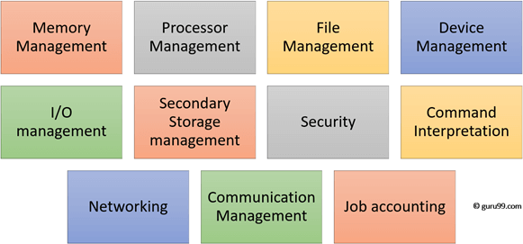

Functions of Operating System

In an operating [system software](https://www.guru99.com/difference-system-software-application-software.html) performs each of the function:

1. **Process management**: Process management helps OS to create and delete processes. It also provides mechanisms for synchronization and communication among processes.
2. **Memory management:** Memory management module performs the task of allocation and de-allocation of memory space to programs in need of this resources.
3. **File management**: It manages all the file-related activities such as organization storage, retrieval, naming, sharing, and protection of files.
4. **Device Management**: Device management keeps tracks of all devices. This module also responsible for this task is known as the I/O controller. It also performs the task of allocation and de-allocation of the devices.
5. **I/O System Management:** One of the main objects of any OS is to hide the peculiarities of that hardware devices from the user.
6. **Secondary-Storage Management**: Systems have several levels of storage which includes primary storage, secondary storage, and cache storage. Instructions and data must be stored in primary storage or cache so that a running program can reference it.
7. **Security**: Security module protects the [data and information](https://www.guru99.com/difference-information-data.html) of a computer system against malware threat and authorized access.
8. **Command interpretation**: This module is interpreting commands given by the and acting system resources to process those commands.
9. **Networking:** A distributed system is a group of processors which do not share memory, hardware devices, or a clock. The processors communicate with one another through the network.
10. **Job accounting**: Keeping track of time & resource used by various job and users.
11. **Communication management**: Coordination and assignment of compilers, interpreters, and another software resource of the various users of the computer systems.

# Features of Operating System (OS)

Here is a list important features of OS:

* Protected and supervisor mode
* Allows disk access and file systems Device drivers Networking Security
* Program Execution
* Memory management Virtual Memory Multitasking
* Handling I/O operations
* Manipulation of the file system
* Error Detection and handling
* Resource allocation
* Information and Resource Protection

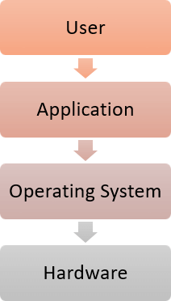

# Advantage of Operating System

* Allows you to hide details of hardware by creating an abstraction
* Easy to use with a GUI
* Offers an environment in which a user may execute programs/applications
* The operating system must make sure that the computer system convenient to use
* Operating System acts as an intermediary among applications and the hardware components
* It provides the computer system resources with easy to use format
* Acts as an intermediator between all hardware’s and software’s of the system

# Disadvantages of Operating System

* If any issue occurs in OS, you may lose all the contents which have been stored in your system
* Operating system’s software is quite expensive for small size organization which adds burden on them. Example Windows
* It is never entirely secure as a threat can occur at any time